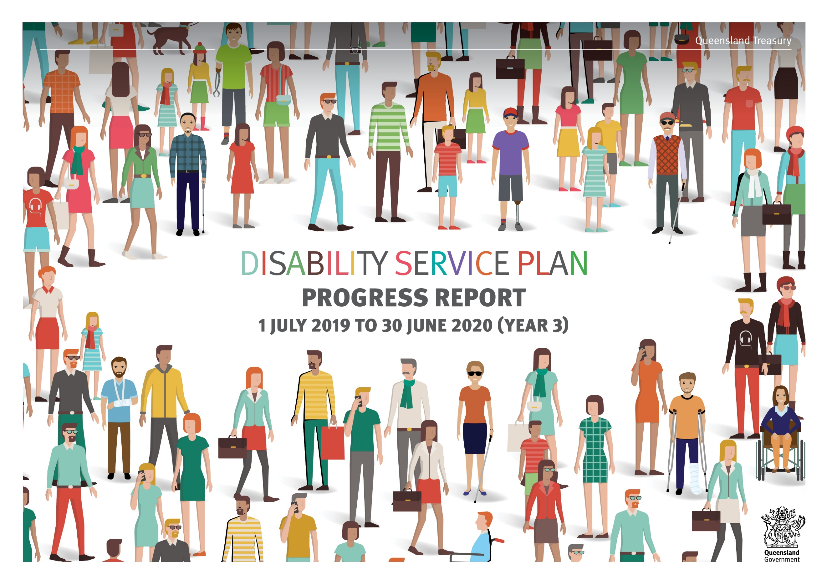

Action  All Abilities Queensland commitments for 2017-2020 | Products/Activities  (for 1 July 2019 to 30 June 2020 (Year 3)) | Progress/Achievements  Ensure success measures are addressed
COMMUNITIES FOR ALL
Changing attitudes and breaking down barriers by raising awareness and capability
Support national communication strategies and activities to promote the National Disability Strategy 2010–2020. | - Participate in and contribute to national disability communication strategies as required.  - Communicate relevant information from Treasury’s Diversity and Inclusion Strategy and Be Healthy, Be Safe, Be Well Strategy to employees. | - 27 articles reinforcing the concepts of Treasury’s Diversity and Inclusion Strategy were published on Treasury’s internal communication channels, including a story focusing on how Treasury is supporting Indigenous Australians with disability.  - Treasury’s Inclusion Matters Statement of Commitment promoted as part of a virtual town hall for employees in June 2020.
Queensland Government Ministers act as champions with business, industry and organisational partners within their portfolio to raise awareness of disability and build partnerships and opportunities. |  | - Treasury will continue to work with Department of Communities, Disability Services and Seniors (DCDSS) to provide Treasury-specific information
Investigate and develop options to provide disability awareness training to Queensland Government frontline staff and to incorporate disability awareness training into Queensland Government induction programs. | - Include disability awareness training in Treasury’s induction program when developed and released by DCDSS. | - Organisational efforts to inform and educate staff about diversity and inclusion is a key step in our maturity journey.  - As at 27 May 2020, 13 staff have completed the DCDSS Disability Awareness training. The training is promoted in line with key events, dates, and initiatives e.g. Disability Action Week, AccessAbility Day.  - Treasury has been considering strategies to increase completion rates:  - The training has been incorporated into induction and onboarding processes as mandatory for all new starters  - Treasury will be mandating completion of the training for all current staff to be completed over the next 12 months.
Encourage Local Governments, non-government organisations and businesses to develop disability access and inclusion plans and use processes to engage with people with disability in the design and delivery of services. | - Undertake stakeholder forums, direct consultation and research to help improve how services are delivered to people who have sustained eligible serious personal injuries in motor vehicle accidents. | - The National Injury Insurance Scheme Queensland (NIISQ) focus on service delivery is directed to supporting people with lived experience of disability.  - In this work NIISQ ensures access and inclusion for people with disability in the design and delivery of NIISQ services. It is also enshrined in NIISQ’s governing legislation and is a foundation of NIISQ’s strategic plan in its participant-centred objectives.  - NIISQ has undertaken a range of measures to progress this objective:  - Engagement with participants through focus group forums to examine how to improve service delivery  - Established a relationship with Queenslanders with Disability Network (QDN) to gain advice on participant service delivery. QDN is a peak body for people with lived experience with disability  - Undertaking its first participant experience survey in 2020-2021  - Initiated a NIISQ Research and Education program to examine, fund and deliver research and education opportunities to benefit participants through partnering with research and education entities.

Action  All Abilities Queensland commitments for 2017-2020 | Products/Activities  (for 1 July 2019 to 30 June 2020 (Year 3)) | Progress/Achievements  Ensure success measures are addressed
Accessible places and spaces
Access for people with disability is improved by considering the needs of people with disability when buildings and venues used by the Queensland Government are refurbished or leases renewed and where possible in choosing venues for Queensland Government run events and meetings. | - Maintain hearing loops in 1 William Street (1WS) conference facilities to help people with hearing impairments.  - Monitor planning for new accommodation/structures to ensure physical structures such as doorways, steps and stairs do not act as barriers to employees and customers with mobility issues.  - Provide information about events accessibility and participation on Treasury’s intranet. | - Information is available on Treasury’s intranet about organising events to ensure accessibility and guidelines on inclusive language.  - Treasury ensures that Concierge maintain hearing loops in 1WS conference facilities to help people with hearing impairments.  - Treasury, in consultation with The Department of Housing and Public Works, monitor planning for new accommodation/structures to ensure physical structures such as doorways, steps and stairs do not act as barriers to employees and customers with mobility issues.  - Destination control lifts provide dedicated functions through the programming of their access card, for officers with visual and hearing impairments and officers with any assisted mobility appliance.  - Details of events are provided on Nexus bitesize news.
Accessible information
Work towards ensuring all Queensland Government information is accessible and provided in multiple formats. | - Publish content on Treasury’s website in HTML or accessible PDF formats and ensure new video or audio content includes captioning. | - Treasury’s external website and intranet are reviewed on an ongoing basis to improve compliance with accessibility standards and performance, and web content accessibility guidelines.
Government policies require Queensland Government websites to meet contemporary Australian Web Content Accessibility Guidelines. Work continues to be undertaken to provide transcripts and/or captions are available for newly created time-based media (i.e. pre-recorded video/audio). | - Ensure Treasury’s websites are scalable and designed with consistent user experience (CUE) and in accordance with web accessibility guidelines.  - Ensure that the department’s intranet content meets web content accessibility guidelines. | - New audio content includes captioning and/or transcripts to improve accessibility.  - The Budget website used HTML content in preference to PDF content which is more accessible for screen-reader software.  - The corporate intranet environment was migrated from Microsoft SharePoint 2013 to Office 365, enabling improvements to the accessibility of intranet content, including providing captions on new corporate videos.
Welcoming and inclusive communities
Promote uptake of the Companion Card Program by businesses, including Queensland Government venues and events. |  | - Treasury will continue to work with DCDSS to provide Treasury-specific information
Respecting and promoting the rights of people with disability and recognising diversity
Work towards ensuring all Queensland Government legislation, policies and programs are consistent with national commitments under international conventions, consider the needs or interests of people with disability and carers and promote and uphold the human rights of people with disability. | - Ensure Treasury’s Managing Corporate Policy Guidance references the requirement to uphold the human rights of people with disability.  - Treasury is working to ensure Queensland legislation, policies and programs within its portfolio responsibilities are reviewed in the context of the whole-of-government implementation of the Human Rights Act 2019. | - Treasury’s Corporate Governance Framework is being updated to incorporate requirements to uphold human rights (including upholding the human rights of people with disability).  - Treasury has completed a comprehensive review of all legislation and decision-making frameworks including policies, procedures, processes and complaint handling practices.  - Treasury’s complaints framework has been updated to include human rights considerations and a Human Rights Complaints management guide has been developed.  - Treasury has established a Legislative Community of Practice and Human Rights Working Groups to help build a culture that respects and promotes human rights, considers legislative impacts and creates dialogue about the nature, meaning and scope of human rights and to share lessons learned.  - Treasury continues to embed human rights through pro-active communications and training initiatives.

Action  All Abilities Queensland commitments for 2017-2020 | Products/Activities  (for 1 July 2019 to 30 June 2020 (Year 3)) | Progress/Achievements  Ensure success measures are addressed
Government services and funded non-government services provide access to language, translating and communication services. | - Information about interpreters and translators is available on Treasury’s intranet.  - Ensure that information about interpreter services is displayed and that interpreters are engaged to help people with limited proficiency in English, or who are deaf or hard of hearing.  - Monitor usage via the Queensland Language Services Policy measure. | - Treasury’s business areas continue to engage interpreters and translators to communicate with people who have a hearing impairment or limited proficiency in English. This has included the engagement of Auslan services at team meetings, staff forums, and training sessions.  - In 2019-20, less than 1% of clients have required language support; $1957 was spent on the engagement of interpreters and translators; and there were 48 occasions were interpreters and translators were engaged by Treasury.
EMPLOYMENT
Leading the way – increasing opportunities in the Queensland public sector
Implement strategies to reach the Queensland Government target that, by 2022, eight per cent of the Queensland Public Sector workforce will be people with disability, across attraction, recruitment, retention and career progression and development, for example flexible work practices and inclusion of people with disability in the government employer brand. | - Review Treasury’s recruitment procedures and guidelines to ensure they are actively inclusive and encouraging to people with a disability and provide sufficient guidance to managers and selection panels when engaging in recruitment practices.  - Review job flexibility policies and procedures to be more inclusive and accommodating of people with disability. | - Treasury remains committed to improving employment outcomes for people with disability and continues to make progress against 2022 foundational diversity targets.  - Treasury monitors its proportion of employees with disability by two methods: Minimum Obligatory Human Resources Information (MOHRI) workforce data (3.05% as at 8 May 2020), and the annual Working for Queensland employee opinion survey data (6.52% as at September 2019).  - Treasury contributes to cross sector discussions and a multi-agency approach to placements that attract and are sustainable in providing retention of employees with disability.  - A Diversity and Inclusion Policy has been developed to directly influence outcomes in relation to employment and promotional opportunities in Treasury. This policy is currently in consultation phase seeking feedback from a variety of diverse groups.  - Treasury holds membership with key expert organisations including Job Access, Diversity Council of Australia and the Australian Network on Disability. We draw tools and resources from these organisations to support our policies and procedures  - The needs and inclusion of people with disability is a key consideration in Treasury’s GRADStart program.
Increasing employment opportunities for Queenslanders with disability
Promote information, resources and examples of the benefits to businesses of employing people with disability, the assistance available, how to make recruitment and employment process more accessible to improve opportunities for people with disability to participate in employment. | - Increase Treasury’s knowledge of support available on recruitment, onboarding and employment of people with disability. | - Treasury hosted two job seekers for AccessAbility day in November 2019. These placements were supported by an accessible onboarding and induction process, including additional training to the business. This was reported as a positive experience for both job seekers and staff members involved. Treasury expects to expand this hosting opportunity in 2020.  - Epilepsy Queensland reposted an internal Treasury article to share the positive experience and create greater awareness (https://www.epilepsyqueensland.com.au/wp-content/uploads/EQ-The-Flame-issue-1-2020-final.pdf).  - Treasury shared DCDSS hosted face to face Disability Awareness for the Workplace sessions held in March 2020 with members in its diversity networks.

Action  All Abilities Queensland commitments for 2017-2020 | Products/Activities  (for 1 July 2019 to 30 June 2020 (Year 3)) | Progress/Achievements  Ensure success measures are addressed
EVERYDAY SERVICES
Disability and community supports
Work with the National Disability Insurance Agency to provide a smooth transition to the National Disability Insurance Scheme. | - In early July 2019, Queensland reached agreement with the Commonwealth on an NDIS Full Scheme Agreement on terms which recognise the delayed transition in this State. The Commonwealth has acknowledged Queensland’s concerns regarding the slow transition and has agreed to continue the Transition Bilateral Agreement for at least 12 months to 30 June 2020. | - This action has been completed following signing of the Bilateral Agreement between the Commonwealth and Queensland Governments on the National Disability Insurance Scheme.  - Treasury will continue to work alongside DCDSS, other jurisdictions, and the Commonwealth Government to manage national policy issues in light of the COVID-19 pandemic.
LEADERSHIP AND PARTICIPATION
Inclusion in consultation, civic participation and decision making and supporting leadership development
Promote inclusion of people with disability on State Government boards, steering committees and advisory bodies to foster ‘change from within’. |  | - Treasury will continue to work with DCDSS to promote inclusion of people with disability on State Government boards, steering committees and advisory bodies, when applicable.
Consultation and engagement processes are offered in a range of ways, including the use of technology, which maximise the participation opportunities for people with disability their families and carers. | - Offer reasonable adjustment when engaging with stakeholders to maximise their participation. | - Where possible formal consultation opportunities have been offered in online environments that support the use of assistive technologies.
Queensland Government agencies consult with people with disability when either developing a Disability Service Plan or implementing Disability Service Plan actions. | - Liaise with Treasury employees with a disability when implementing DSP actions. | - Treasury’s consultative networks have been involved in the review and development of Treasury plans and implementation of actions.  - Treasury incorporated additional diversity and inclusion related questions in the 2019 Working for Queensland employee opinion survey, in relation to how comfortable employees feel in sharing their diversity information.  - 82.08% of staff that responded indicated they are comfortable sharing their diversity information; 62.30% of those respondents indicated having an impairment (disability).  - Treasury will consider strategies for effective consultation and engagement with staff to increase safe self-disclosure, and to further inform strategy development and review processes.
Existing leadership programs are accessible and inclusive of Queenslanders with disability. | - Ensure the application process, content, structure and delivery of Treasury’s capability development offerings meet the needs of people with disability. | - Participant demographics for Treasury leadership and capability development programs are representative of the community.

Action  Queensland Treasury DSP commitments for 2017-20 | Products/Activities  (for 1 July 2019 to 30 June 2020 (Year 3)) | Progress/Achievements  Ensure success measures are addressed
Undertake health and safety audits to identify potential hazards that may obstruct or be inadequate for employees or customers with a disability. | - Undertake regular workplace audits to identify and eradicate potential hazards for people with disability. | - Annual workplace health and safety hazard audits were carried out across all floors of Treasury.  - Treasury regularly monitors and assesses incident reports.  - Quarterly Workplace Health and Safety Consultative network meetings provide opportunities for employee representatives to raise matters for consideration.
Continue to ensure that Queensland Treasury employees with a disability receive appropriate support and technology to perform their job. | - Engage specialists to identify the adjustments, technologies and workplace modifications required for staff.  - Regularly review reasonable adjustments and assistive technologies to ensure they continue to meet the needs of staff. | - Treasury is currently responding to a request for reasonable adjustment to allow an assistance animal at the workplace. As part of these considerations, the department will look at the benefits to health and workplace factors.  - Workstation assessments (with an external allied health professional) can be organised for employees who have a significant injury or a specific requirement.  - Telehealth assessments can be also be completed via Skype, Microsoft Teams, and Telephone, for employees who are working from home.
Promote Treasury’s internal Diversity and Inclusion groups. | - Assist in the development of strategies to improve Treasury’s inclusive culture.  - Actively promote and encourage staff participation in diversity and inclusion activities and events. | - Quarterly Diversity and Inclusion Steering Committee meetings, chaired by the Under Treasurer, provides formal governance, guidance and direction to diversity and inclusion strategy and policy across the department.  - This group is supported by the Diversity and Inclusion Employee Network made up of inclusion allies at a local level from across the organisation.
Executive Leadership Team members champion and promote Disability Action Week. | - Promotion of Disability Action Week. | - In support of Disability Action Week 2019, Treasury collaborated with other Queensland Government agencies to provide all staff with an award-winning film experience, Wide Angle Film Festival (WAFF), which reflects the lived experience of people with disability.  - Staff were encouraged to:  - Complete the DCDSS Disability Awareness training  - Explore the Public Service Commission’s Disabling the Barriers Knowledge Centre to learn how to make workplaces accessible  - Advertise a vacant role through Disability Employment Service providers  - Visit All Abilities Queensland for practical recruitment information.
Support the National Injury Insurance Scheme Queensland’s (NIISQ) provision of necessary and reasonable treatment, care and support services to people who sustain serious eligible personal injuries in motor vehicle accidents. | - NIISQ will help people with serious eligible personal injuries:  - With funding for services that enable them to join in community activities.  - By promoting and respecting their rights and dignity through inclusion, equality and non-discrimination.  - With funding for necessary and reasonable education and vocational training to promote their independence and return to work where appropriate. | - Treasury and the Office of Industrial Relations, Department of Education, have commenced consultation on a Regulatory Impact Statement with options for regulations specifying the timeframe and conditions under which a person with an eligible injury who exited NIISQ after accepting treatment, care and support damages may be readmitted to the Scheme.  - NIISQ continues to deliver its statutory obligations to ensure necessary and reasonable treatment care and support is provided to eligible persons under the NIISQ Act.  - Initiated a NIISQ Research and Education program to examine, fund and deliver research and education opportunities to benefit participants through partnering with research and education entities.  - Under the legislation, NIISQ is required to and operates to consult participants in decision making regarding treatment care and support. NIISQ has implemented tools to support participants being involved in decision making. This includes contributing to their attendant care and support planning with service providers through a templated My Attendant Care and Support Plan.

Action  Queensland Treasury DSP commitments for 2017-20 | Products/Activities  (for 1 July 2019 to 30 June 2020 (Year 3)) | Progress/Achievements  Ensure success measures are addressed
Invest in targeted research to improve health and participation outcomes for people injured in motor vehicle crashes. | - A range of projects are being funded that align to the CTP scheme’s research priorities with a focus on traumatic brain, psychological and whiplash injuries.  - Recent funding includes $5 million over the next 3 years to the Griffith Institute for Drug Discovery to improve functional recovery for those with permanent spinal cord injuries. | - The Motor Accident Insurance Commission (MAIC) provides funding to:  - Griffith University to improve functional recovery for those with permanent spinal cord injuries  - Spinal Life Australia to support operations of the Spinal Education Awareness Team (SEAT) and vocational rehabilitation program for people with spinal cord injuries (Back2Work)  - Fellowship at Queensland Brain Institute to undertake a prospective longitudinal study focus of identification of biomarkers that could be used for the prediction of patient outcomes in those with moderate to severe traumatic brain injury.  - MAIC delivers operational support to the Hopkins Centre at Griffith University who undertake a program of translation research in the field of rehabilitation and severe disability.  - NIISQ has initiated a Research and Education program to examine, fund and deliver research and education opportunities to benefit participants through partnering with research and education entities.
Invest in research and work with the Department of Transport and Main Roads (DTMR) and the Queensland Police Service (QPS) to improve road safety and prevent transport-related injuries that could result in CTP claims and long-term disabilities. | - Program of research activities developed in conjunction with Queensland Police Service (QPS) and Department of Transport and Main Roads (DTMR) to reduce accident frequency and CTP scheme costs. | - MAIC’s Road Trauma Mitigation Fund continues to be in operation which provides support to QPS and DTMR:  - Establishment of Road Safety Data bureau involving QPS, TMR, MAIC and Queensland Health which will provide greater insights into crash circumstances to inform potential countermeasures  - Funded research into drug driving a behaviour which is overrepresented in terms of serious crashes and injuries  - Funded research into motorcycle safety – a vulnerable road user cohort that is overrepresented in terms of involvement in crashes resulting in disability.

