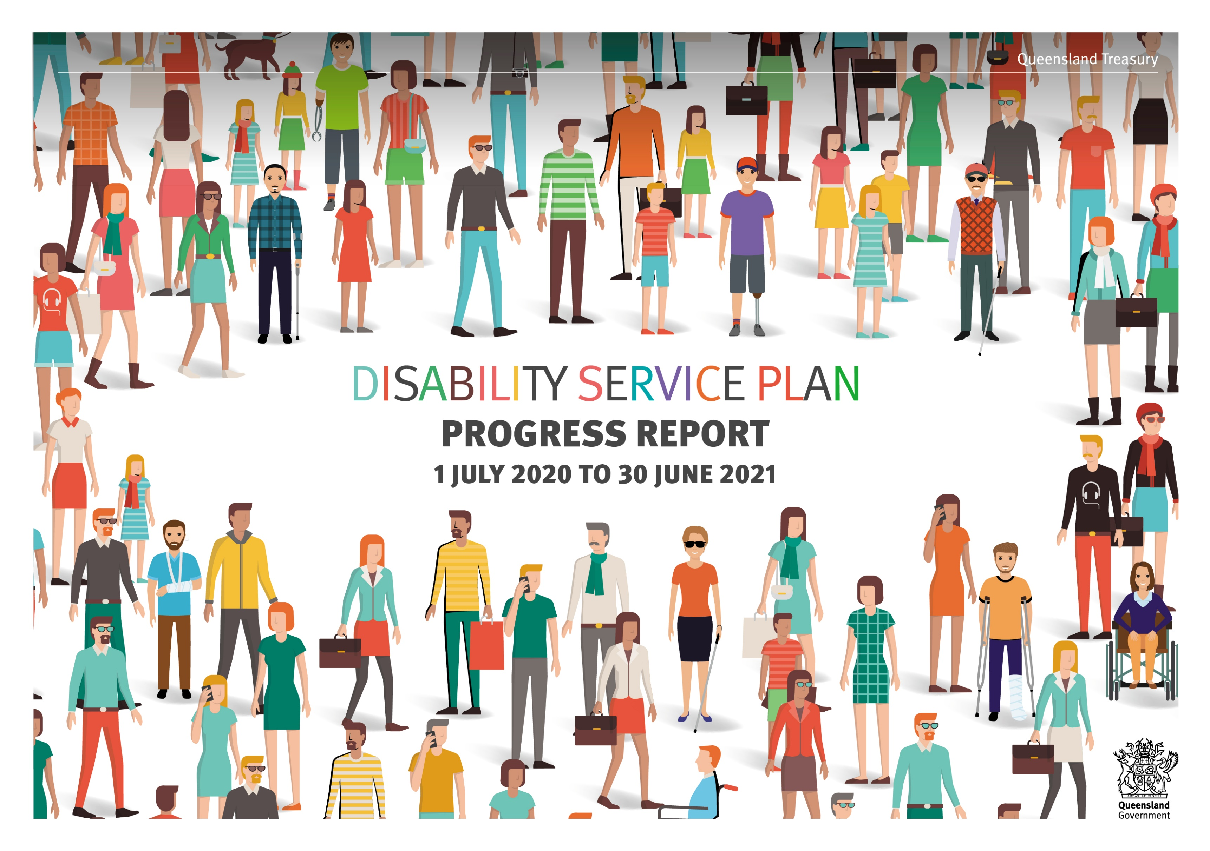

Action  All Abilities Queensland commitments for 2017-2020 | Products/Activities  (for 1 July 2020 to 30 June 2021) | Progress/Achievements  Ensure success measures are addressed
COMMUNITIES FOR ALL
Changing attitudes and breaking down barriers by raising awareness and capability
Support national communication strategies and activities to promote the National Disability Strategy 2010–2020. | - Participate in and contribute to national disability communication strategies as required.  - Communicate relevant information from Treasury’s Diversity and Inclusion Strategy and Be Healthy, Be Safe, Be Well Strategy to employees. | Treasury used its internal communication channels (eNewsletter, Virtual Town Halls, Under Treasurer emails) to promote diversity and inclusion including:  - inclusiveness as a foundation of Treasury’s workforce strategy  - employees’ personal lived experience of diversity in Virtual Town Halls  - leader-led encouragement of inclusion and diversity  - employee participation in whole-of-government and external programs such as Diversity Council Australia events and scholarship programs  - showcasing Motor Accident Insurance Commission’s (MAIC) research investment in programs to support people living with disability.
Queensland Government Ministers act as champions with business, industry and organisational partners within their portfolio to raise awareness of disability and build partnerships and opportunities. |  | - Treasury continues to work with Department of Seniors, Disability Services and Aboriginal and Torres Strait Islander Partnerships (DSDSATSIP) to provide Treasury-specific information.
Investigate and develop options to provide disability awareness training to Queensland Government frontline staff and to incorporate disability awareness training into Queensland Government induction programs. | - Include disability awareness training in Treasury’s induction program. | - Treasury's Diversity and Inclusion policy (approved in December 2020) enlivens our commitment to ensure all staff complete diversity and cultural capability training – including the disability awareness training.  - Treasury transitioned to a new Learning Management System in July 2021 and disability awareness training was provided to all staff to complete and has been incorporated into the induction program.
Encourage Local Governments, non-government organisations and businesses to develop disability access and inclusion plans and use processes to engage with people with disability in the design and delivery of services. | - Undertake stakeholder forums, direct consultation and research to help improve how services are delivered to people who have sustained eligible serious personal injuries in motor vehicle accidents. | - The National Injury Insurance Scheme Queensland (NIISQ) has continued to focus on the provision of necessary and reasonable treatment, care and support for people who acquire ongoing disability as a result of a motor vehicle accident in Queensland.  - In 2020-2021, NIISQ:  - successfully undertook its first participant survey, achieving overwhelmingly positive and valuable feedback that is being used to continue to improve service delivery  - engaged the First Peoples Disability Network to provide refresher training in targeted support planning tools for Aboriginal and Torres Strait Islander participants  - delivered a joint presentation with WorkCover Qld to the 2021 Personal Injury and Disability Management conference, focusing on case studies where participant-driven support planning approaches have delivered exceptional outcomes  - continued to build on its relationship with Queenslanders with Disability Network (QDN) with a view to establishing a Participant Reference Group in 2021/2022  - supported NIISQ Research and Education program partnerships that include meaningful involvement of people with a disability.

Action  All Abilities Queensland commitments for 2017-2020 |  |  | Products/Activities  (for 1 July 2020 to 30 June 2021) | Progress/Achievements  Ensure success measures are addressed
Accessible places and spaces
Access for people with disability is improved by considering the needs of people with disability when buildings and venues used by the Queensland Government are refurbished or leases renewed and where possible in choosing venues for Queensland Government run events and meetings. |  |  | - Maintain hearing loops in 1 William Street (1WS) conference facilities to help people with hearing impairments.  - Monitor planning for new accommodation/structures to ensure physical structures such as doorways, steps and stairs do not act as barriers to employees and customers with mobility issues.  - Provide information about event accessibility and participation on Treasury’s intranet. | - Information is available on Treasury’s intranet about organising events to ensure accessibility and guidelines on inclusive language.  - Treasury ensures that hearing loops are maintained in 1WS conference facilities to help people with hearing impairments.  - Treasury, in consultation with the Department of Energy and Public Works, monitor planning for new accommodation/structures to ensure physical structures such as doorways, steps and stairs do not act as barriers to employees and customers with mobility issues.  - Destination control lifts provide dedicated functions through the programming of access cards for officers with visual and hearing impairments and officers with any assisted mobility appliance.  - Details of events are provided via communication channels on the Nexus Home Page.
Accessible information
Work towards ensuring all Queensland Government information is accessible and provided in multiple formats. |  |  | - Publish content on Treasury’s website in HTML or accessible PDF formats and ensure new video or audio content includes captioning. | - Treasury’s websites and intranets are reviewed on an ongoing basis to ensure accessibility and compliance, new content additions meet accessibility guidelines.
Government policies require Queensland Government websites to meet contemporary Australian Web Content Accessibility Guidelines. Work continues to be undertaken to provide transcripts and/or captions for newly created time-based media (i.e. pre-recorded video/audio). |  |  | - Ensure Treasury’s websites are scalable and designed with consistent user experience (CUE) and in accordance with web accessibility guidelines.  - Ensure that the department’s intranet content meets web content accessibility guidelines. | - In 2021 Treasury updated its Style Guide to reflect changes to the APS Style Guide to improve accessibility and optimise written communication for people using screen reader software and refreshed advice around inclusive language.  - The Budget website delivered more products in HTML content in 2021 including 13 Regional Action Plans in HTML for the first time.
 | Welcoming and inclusive communities
 | Promote uptake of the Companion Card Program by businesses including Queensland Government venues and events. |  |  |  | - Treasury continues to work with DSDSATSIP to provide Treasury-specific information.
 | Respecting and promoting the rights of people with disability and recognising diversity
 | Work towards ensuring all Queensland Government legislation, policies and programs are consistent with national commitments under international conventions, consider the needs or interests of people with disability and carers and promote and uphold the human rights of people with disability. | - Ensure Treasury’s Managing Corporate Policy Guidance references the requirement to uphold the human rights of people with disability.  - Treasury is working to ensure Queensland legislation, policies and programs within its portfolio responsibilities are reviewed in the context of the whole-of-government implementation of the Human Rights Act 2019. |  |  | - Treasury’s Corporate Governance Framework incorporates requirements to uphold human rights (including upholding the human rights of people with disability).  - A Human Rights Complaints Management Guide was implemented in October 2020 and assists Treasury officers in managing complaints that include a human rights element.  - Treasury’s complaints management framework provides that human rights must be considered for all complaints and includes links to Treasury’s Human Rights Complaints Management Guide and other associated material.  - Treasury has established two Communities of Practice (CoP) – the “Complaints and Decision-making CoP” and the “Legislative CoP”. These communities meet quarterly. The objectives of the communities are to support broad collaboration and information sharing on human rights issue, complaints management and best practice, as well as capability building for the CoP members

Action  All Abilities Queensland commitments for 2017-2020 |  | Products/Activities  (for 1 July 2020 to 30 June 2021) | Progress/Achievements  Ensure success measures are addressed
Respecting and promoting the rights of people with disability and recognising diversity
 | Government services and funded non-government services provide access to language, translating and communication services. | - Information about interpreters and translators is available on Treasury’s intranet.  - Ensure that information about interpreter services is displayed and that interpreters are engaged to help people with limited proficiency in English, or who are deaf or hard of hearing.  - Monitor usage via the Queensland Language Services Policy measure. | - Treasury’s business areas continue to engage interpreters and translators to communicate with people who have a hearing impairment or limited proficiency in English.  - In 2020-21, less than 1% of clients have required language support, $2405 was spent on the engagement of interpreters and translators, and there where 64 occasions were interpreters and translators were engaged by Treasury.
 | EMPLOYMENT
 | Leading the way – increasing opportunities in the Queensland public sector
 | Implement strategies to reach the Queensland Government target that, by 2022, eight per cent of the Queensland Public Sector workforce will be people with disability, across attraction, recruitment, retention and career progression and development, for example flexible work practices and inclusion of people with disability in the government employer brand. | - Review Treasury’s recruitment procedures and guidelines to ensure they are actively inclusive and encouraging to people with a disability and provide sufficient guidance to managers and selection panels when engaging in recruitment practices.  - Review job flexibility policies and procedures to be more inclusive and accommodating of people with disability. | - Treasury remains committed to improving employment outcomes for people with disability and continues to make progress against 2022 foundational diversity targets.  - Treasury monitors its proportion of employees with disability by two methods: Minimum Obligatory Human Resources Information (MOHRI) workforce data (2.99% as at June 2021) and the annual Working for Queensland (WfQ) employee opinion survey data (11.7% as at September 2020). Note that the MOHRI definition will be updated in August 2021 to align with the WfQ survey.  - Treasury contributes to cross sector discussions and a multi-agency approach to placements that attract and are sustainable in providing retention of employees with disability.  - Treasury's Diversity and Inclusion policy (approved in December 2020) affirms our commitment to improving recruitment outcomes for people with disability by applying appropriate diversity measures and strategy across all recruitment and selection exercises.  - Treasury holds membership with key expert organisations including Diversity Council of Australia and the Australian Network on Disability. We draw tools and resources from these organisations to support our policies and procedures.  - The needs and inclusion of people with disability is a key consideration in Treasury’s Graduate Recruitment program.
 | Increasing employment opportunities for Queenslanders with disability
 | Promote information, resources and examples of the benefits to businesses of employing people with disability, the assistance available, how to make recruitment and employment process more accessible to improve opportunities for people with disability to participate in employment. | - Increase Treasury’s knowledge of support available on recruitment, onboarding and employment of people with disability. | - Treasury signed up to the “Stepping Into” Program which is delivered through the Australian Network on Disability. This program provides opportunities for university students with disability to gain meaningful work experience and Treasury, as an employer, the opportunity to increase our disability recruitment confidence. Recruitment activities for two placements commenced in May 2021, with interns commencing in July 2021.  - Treasury’s intranet was updated in early 2021 with content, resources and training relating to inclusive recruitment practices. These practices are being embedded in recruitment processes throughout 2021.

Action  All Abilities Queensland commitments for 2017-2020 |  | Products/Activities  (for 1 July 2020 to 30 June 2021) | Progress/Achievements  Ensure success measures are addressed
 | LEADERSHIP AND PARTICIPATION
 | Inclusion in consultation, civic participation and decision making and supporting leadership development
 | Promote inclusion of people with disability on State Government boards, steering committees and advisory bodies to foster ‘change from within’. |  | - Treasury continues to work with DSDSATSIP to promote inclusion of people with disability on State Government boards, steering committees and advisory bodies, when applicable.
 | Consultation and engagement processes are offered in a range of ways, including the use of technology, which maximise the participation opportunities for people with disability their families and carers. | - Offer reasonable adjustment when engaging with stakeholders to maximise their participation. | - Where possible formal consultation opportunities have been offered in online environments that support the use of assistive technologies.
 | Queensland Government agencies consult with people with disability when either developing a Disability Service Plan or implementing Disability Service Plan actions. | - Liaise with Treasury employees with a disability when implementing DSP actions. | - Treasury’s consultative networks have been involved in the review and development of Treasury plans and implementation of actions.  - Treasury incorporated additional diversity and inclusion related questions to the 2020 Working for Queensland employee opinion survey in relation to how comfortable employees feel in sharing their diversity information. 73% of respondents living with disability indicated they are comfortable sharing their diversity information – which is an increase of 11% compared to the 2019 survey.  - Treasury will consider strategies for effective consultation and engagement with staff to increase safe self-disclosure, and to further inform strategy development and review processes.
 | Existing leadership programs are accessible and inclusive of Queenslanders with disability. | - Ensure the application process, content, structure and delivery of Treasury’s capability development offerings meet the needs of people with disability. | - A diversity and inclusion lens is applied to Treasury's leadership programs to monitor the representation within cohorts.

Action  Queensland Treasury DSP commitments for 2017-20 | Products/Activities  (for 1 July 2020 to 30 June 2021) | Progress/Achievements  Ensure success measures are addressed
Undertake health and safety audits to identify potential hazards that may obstruct or be inadequate for employees or customers with a disability. | - Undertake regular workplace audits to identify and eradicate potential hazards for people with disability. | - Annual workplace health and safety hazard audits were carried out across all business locations.  - Treasury regularly monitors and assesses incident reports.  - Additional WHS network meetings were conducted to keep abreast of the COVID-19 challenges.  - Consideration of workplace reasonable adjustment is considered on an individual basis.
Continue to ensure that Queensland Treasury employees with a disability receive appropriate support and technology to perform their job. | - Engage specialists to identify the adjustments, technologies and workplace modifications required for staff.  - Regularly review reasonable adjustments and assistive technologies to ensure they continue to meet the needs of staff. | - Treasury reviewed all work arrangements as well as individual adjustments in context of COVID-19 experiences/shutdowns.  - Consideration of a range of technologies were considered to meet all-staff needs during the shutdown (COVID) periods.  - Immediate family members accessed Employee Assistance Program (EAP) psychological counselling (in addition to staff access).  - Additional online tools were developed and offered by the EAP to support workers. Examples: Resilience Toolkit and personal coaching.
Promote Treasury’s internal Diversity and Inclusion groups. | - Assist in the development of strategies to improve Treasury’s inclusive culture.  - Actively promote and encourage staff participation in diversity and inclusion activities and events. | - Quarterly Diversity and Inclusion Steering Committee meetings, chaired by the Under Treasurer, provides formal governance, guidance and direction to diversity and inclusion strategy and policy across the department.  - This group is supported by the Diversity and Inclusion Employee Network made up of inclusion allies at a local level from across the organisation.
Executive Leadership Team members champion and promote Disability Action Week. | - Promotion of Disability Action Week. | - In support of Disability Action Week 2020, Treasury hosted a Virtual Town Hall with then Under Treasurer, Ms Rachel Hunter, and a guest speaker, Mr Andrew Hartwell, from Australian Network on Disability. The event was well-attended by Treasury staff. This event highlighted equitable access to opportunities for people from diverse backgrounds – from recruitment to career development – is essential to boosting our productivity and ensuring everyone has an opportunity to participate to their full potential.  - As part of all-staff communications, staff were:  - asked to complete the Disability Awareness training; and  - encouraged to attend a virtual event: ‘Mind the Gap: Bridging the Disability Divide’ delivered by Queenslanders with Disability Network.
Invest in research and work with the Department of Transport and Main Roads (DTMR) and the Queensland Police Service (QPS) to improve road safety and prevent transport-related injuries that could result in CTP claims and long-term disabilities. | - Program of research activities developed in conjunction with Queensland Police Service (QPS) and Department of Transport and Main Roads (DTMR) to reduce accident frequency and CTP scheme costs. | - Road Trauma Mitigation Fund continues operations during 2020-21 and provided support to QPS and TMR including:  - the establishment of Road Safety Data bureau involving QPS, TMR, MAIC and Queensland Health which will provide greater insights into crash circumstances to inform potential countermeasures  - funding a pilot study into distracted driving, looking at new technology to detect mobile phone and seatbelt compliance  - funding contribution towards the implementation of a new hazard perception test for novice drivers  - funding research into drink driving which will form the basis of a suite of newly legislated interventions which will be introduced in Queensland in 2021-22.

Action  Queensland Treasury DSP commitments for 2017-20 | Products/Activities  (for 1 July 2020 to 30 June 2021) | Progress/Achievements  Ensure success measures are addressed
Support the National Injury Insurance Scheme Queensland’s (NIISQ) provision of necessary and reasonable treatment, care and support services to people who sustain serious eligible personal injuries in motor vehicle accidents. | - NIISQ will help people with serious eligible personal injuries:  - With funding for services that enable them to join in community activities.  - By promoting and respecting their rights and dignity through inclusion, equality and non-discrimination.  - With funding for necessary and reasonable education and vocational training to promote their independence and return to work where appropriate. | - As at 30 June 2021, NIISQ was providing necessary and reasonable treatment care and support for:  - 282 participants with traumatic brain injuries  - 68 participants with spinal cord injuries  - 7 participants with brachial plexus injuries  - 9 participants with high level/multiple limb amputations or permanent blindness  - 1 participant with severe burns, and  - 1 participant with permanent blindness caused by trauma.  - Funded supports for participants are based on individualised support plans that are developed together with participants, their families and carers. Supports can include:  - In home and community access supports  - Vocational rehabilitation and return to work services  - Therapy and capacity building supports  - Aids and equipment  - Home and vehicle modifications  These supports enable participants to improve their connections with their communities and to pursue their goals, including return to work, study or meaningful pursuits and to family life.  - Initiated key projects through the NIISQ Research and Education program to benefit NIISQ participants, including:  - The development of physiotherapy clinical practice guidelines for people with spinal cord injury – Queensland component; expected project completion March 2023 (collaboration with Metro South Health)  - Capacity building pilot for providers of cognitive rehabilitation to people with a brain injury; expected project completion May 2022 (collaboration with the University of Queensland)  - Prevention and management of pressure injuries for wheelchair users using advanced manufacturing of personalised cushions; expected project completion July 2022 (collaboration with Metro North Health).
Invest in targeted research to improve health and participation outcomes for people injured in motor vehicle crashes. | - A range of projects are being funded that align to the CTP scheme’s research priorities with a focus on traumatic brain, psychological and whiplash injuries.  - Recent funding includes $5 million over the next 3 years to the Griffith Institute for Drug Discovery to improve functional recovery for those with permanent spinal cord injuries. | - The Motor Accident Insurance Commission (MAIC) provides funding to:  - Griffith University to improve and restore functional recovery for those with permanent spinal cord injuries using stem cell transplants under the Spinal Cord Therapy project; and using thought-control, electrical stimulation and drug therapy under the BioSpine project  - Spinal Life Australia to support operations of the vocational rehabilitation program for people with spinal cord injuries (Back2Work)  - Queensland Brain Institute for a fellowship to undertake a prospective longitudinal study to identify biomarkers that could be used for the prediction of patient outcomes in those with moderate to severe traumatic brain injury  - Bionics Queensland to improve and expand rehabilitation technologies such as bionic devices, implants and treatments to provide better quality of life for those injured in road crashes.  - MAIC provides operational funding to the Hopkins Centre at Griffith University to undertake a program of translation research in the field of rehabilitation and severe disability.

